**SUPPLY CHAIN ANALYSIS**

**FASHION AND BEAUTY**

**SQL SERVER**

**Importing Data:**

**Created database as FashionandBeauty**

**Imported Supply_Chain_Data.CSV file with schema dbo.supplychain**

**## Total Revenue:**

select round(sum(Revenue_generated),2) as Total_Revenue

from dbo.supplychain;

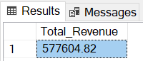

**## Highest Selling Product:**

select Product_type, sum(Number_of_products_sold) as Total_Sales_Count

from dbo.supplychain

group by Product_type

order by Total_Sales_Count desc;

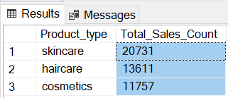

**## Production Volume:**

select sum(Production_volumes) as Total_Production_Volume

from dbo.supplychain;

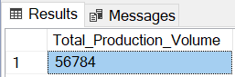

**## Highest Selling Customer:**

select Customer_demographics, sum(Number_of_products_sold) as Total_Sales_Count

from dbo.supplychain

group by Customer_demographics

order by Total_Sales_Count desc;

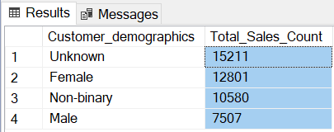

**## Average Defect Rate by Product Type:**

select Product_type, round(avg(Defect_rates),2) as Avg_Defect_Rate

from dbo.supplychain

group by Product_type

order by Avg_Defect_Rate desc;

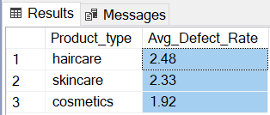

**## Average Manufacturing cost:**

select avg(Manufacturing_costs) as Avg_Manufacturing_Cost

from dbo.supplychain;

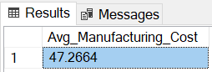

**## Average Manufacturing Lead Time:**

select round(avg(cast(Manufacturing_lead_time as float)),0) as Avg_Manufacturing_Lead_Time

from dbo.supplychain;

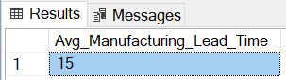

**## Product Availability by SKU (Top 20):**

select SKU, round(sum(cast(Availability as float)),2) as Availability

from dbo.supplychain

group by SKU

order by Availability desc

offset 0 rows

fetch next 20 rows only;

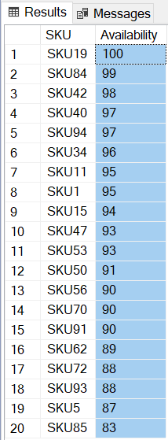

**## Total Product Sold:**

select sum(Number_of_products_sold) as Total_Sales_Count

from dbo.supplychain;

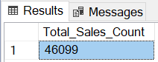

**## Order Quantity by Inspection Results:**

select Inspection_results, sum(cast(Order_quantities as float)) as Total_Order

from dbo.supplychain

group by Inspection_results

order by Total_Order desc;

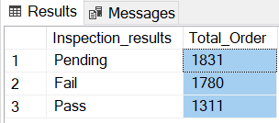

**## Order Quantity by SKU (Top 20):**

select SKU, sum(cast(Order_quantities as float)) as Total_Order

from dbo.supplychain

group by SKU

order by Total_Order desc

offset 0 rows

fetch next 20 rows only;

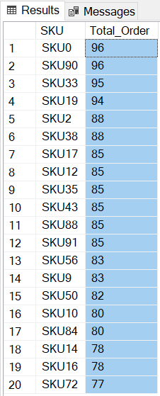

**## Revenue Generated by Supplier:**

select Supplier_name, round(sum(Revenue_generated),2) as Total_Revenue

from dbo.supplychain

group by Supplier_name

order by Total_Revenue desc;

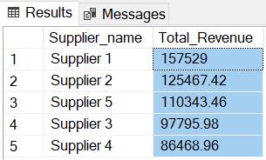

**## Revenue Generated by Shipping Carriers:**

select Shipping_carriers, round(sum(Revenue_generated),2) as Total_Revenue

from dbo.supplychain

group by Shipping_carriers

order by Total_Revenue desc;

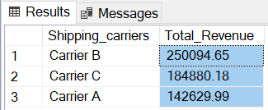

**## Stock Levels by SKU (Top 20):**

select SKU, sum(cast(Stock_levels as float)) as Total_Stock_Levels

from dbo.supplychain

group by SKU

order by Total_Stock_Levels desc

offset 0 rows

fetch next 20 rows only;

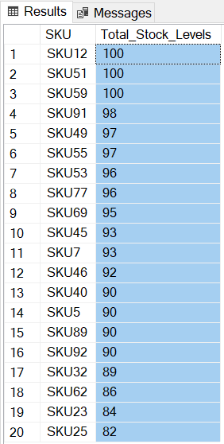

**## Revenue Generated by SKU (Top 20):**

select SKU, round(sum(Revenue_generated),2) as Total_Revenue

from dbo.supplychain

group by SKU

order by Total_Revenue desc

offset 0 rows

fetch next 20 rows only;

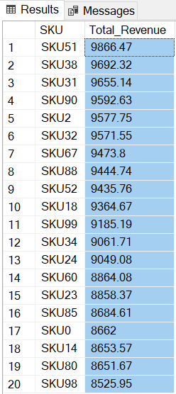

**## Revenue Generated by Product Type:**

select Product_type, round(sum(Revenue_generated),2) as Total_Revenue

from dbo.supplychain

group by Product_type

order by Total_Revenue desc;

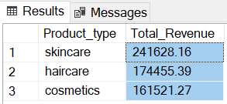

**## Revenue Generated by Location:**

select Location, round(sum(Revenue_generated),2) as Total_Revenue

from dbo.supplychain

group by Location

order by Total_Revenue desc;

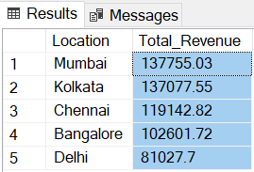

**## Average Lead Time:**

select avg(cast(Lead_time as float)) as Avg_Lead_Time

from dbo.supplychain;

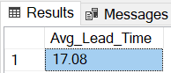

**## Average Shipping Cost:**

select round(avg(Shipping_costs),0) as Avg_Shipping_Cost

from dbo.supplychain;

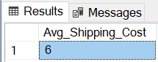

**## Shipping Cost by Each Carriers:**

select Shipping_carriers, round(Sum(Shipping_costs),2) as Total_Shipping_Cost

from dbo.supplychain

group by Shipping_carriers

order by Total_Shipping_Cost desc;

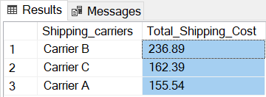

**## Defect Rates by Transportation Modes:**

select Transportation_modes, sum(Defect_rates) as Defect_rates

from dbo.supplychain

group by Transportation_modes

order by Defect_rates desc;

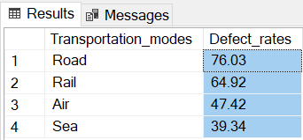

**## Shipping Cost by Transportation Modes:**

select Transportation_modes, sum(Shipping_costs) as Total_Shipping_Cost

from dbo.supplychain

group by Transportation_modes

order by Total_Shipping_Cost desc;

